Zenit-12 XPS
Produced: c.1990  Name: „Зenit-12xps“  Producer: KMZ  Frame size: 24x36.  Lens: -  Shutter: 1/30s-1/500s + B.  Quantity: apr. 40.000 units. | 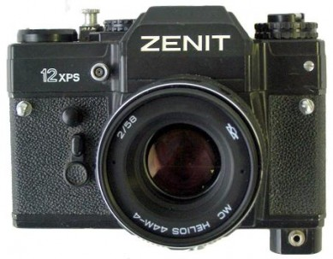
 | Zenit-12xps #93019030.

